15th January 2025
Dear Parents and Carers

Election of Parent Governor

I write to invite you to consider standing for election as a Parent Governor for King Edward VI School Lichfield, or to nominate another parent/carer to do so. We are seeking nomination for one Parent Governor.

Nominations must be from parents or carers with children at King Edward VI School on the day that nominations close. Parent Governors are elected to serve a four-year period. Attached are the eligibility rules for serving as a Governor.

The role of a Parent Governor

The Governing Board has overall responsibility for the running of the school, with three core strategic functions:
- ensuring clarity of vision, ethos and strategic direction
- holding senior staff to account for the educational performance of the school and its pupils
- overseeing the financial performance of the school and making sure its money is well spent.

A Parent Governor should have a keen interest in the school and be prepared to play an active part in the Governing Board’s work. An induction will be arranged for new Governors, and other opportunities for training and development will be provided. The role, responsibilities and expected time commitment of a King Edward VI School Governor are set out in further detail in the attached description.

The children at our school come from a range of different backgrounds and we are keen that our Governing Board is similarly diverse. We therefore welcome nominations from people who are from a minority ethnic background and/or consider themselves to have a disability.

Nomination process

If you would like to nominate yourself or another parent/carer, please complete the attached nomination form, with a scanned signature, and email it to Samantha Jones, Clerk to Governors, sjones@keslichfield.org.uk. Alternatively, the form may be posted to: Samantha Jones, Clerk to Governors, King Edward VI School, Upper St. John Street, Lichfield, WS14 9EE, or it can be handed into the main School reception. Nomination forms must be received by Friday 31st January 2025. If you are nominating another parent/carer, you should seek their prior consent.

Anyone standing for election is invited to provide, with his/her nomination, a short personal statement (maximum 250 words). The statement should include:
- biographical information
- your reasons for wanting to be a Parent Governor
- the contribution you believe you can make to the Governing Board.
If there is only one nominee, they will be automatically elected as Parent Governor. If there is more than one nominee, an election will be held, and candidates’ personal statements and ballot procedure will be circulated to all parents/carers.

I do hope you will consider standing as a Parent Governor yourself or nominating someone else. If you would like more information about the role, please contact Samantha Jones.

Yours faithfully
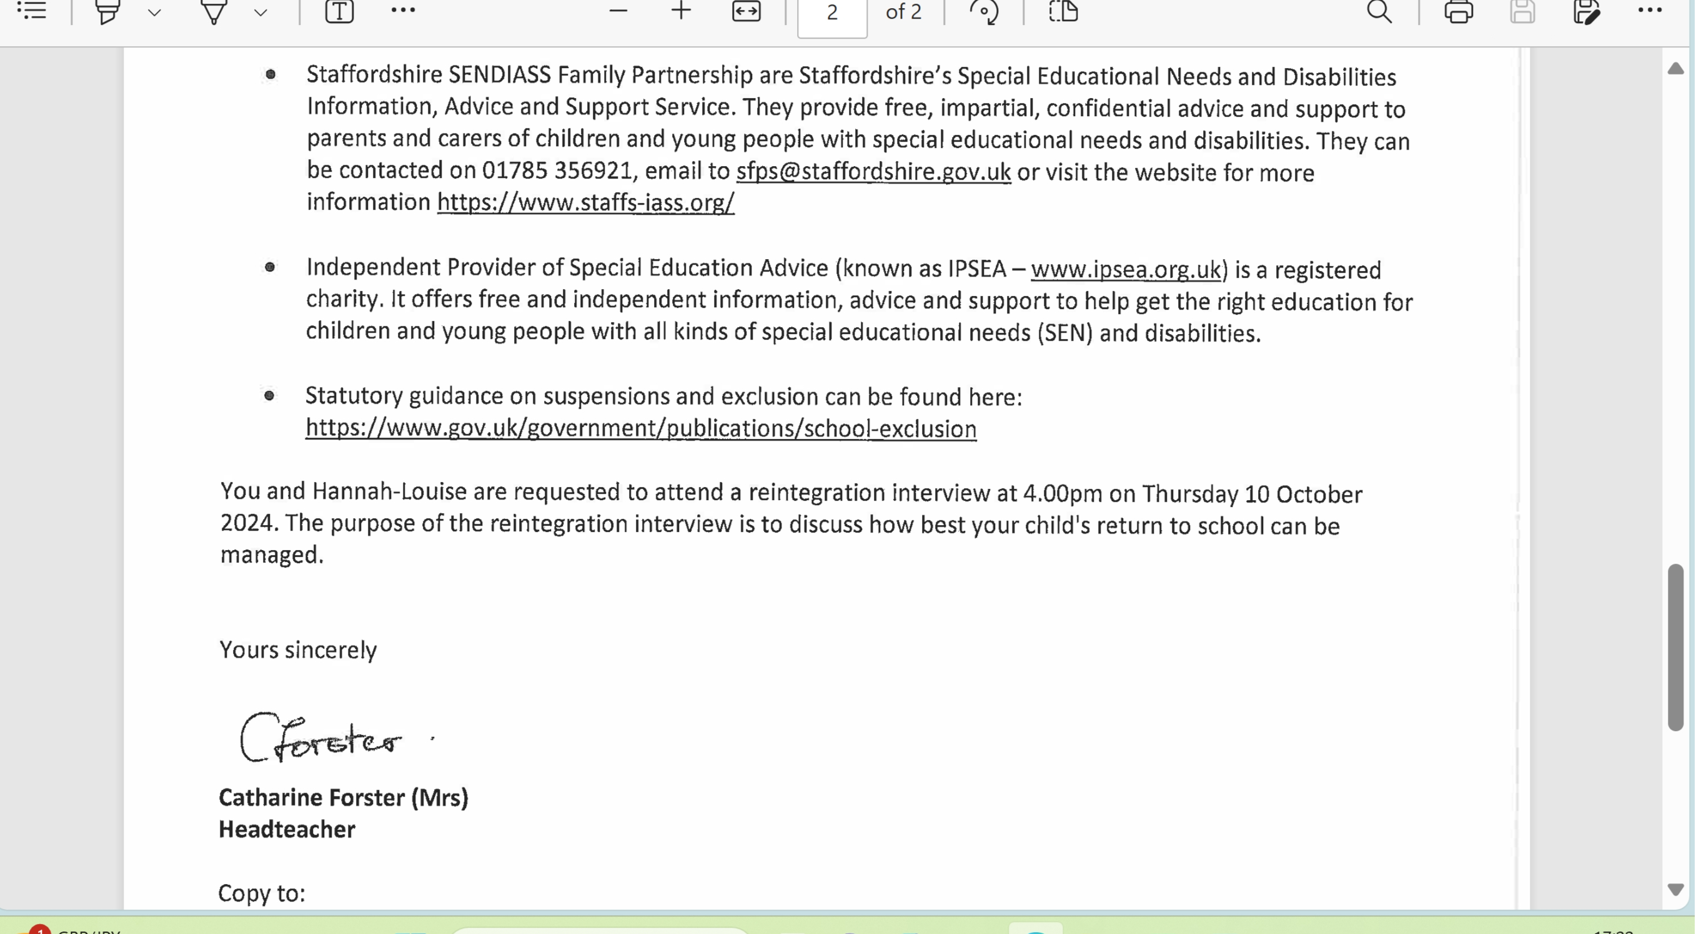
Catherine Forster
Headteacher and Returning Officer

Election of Parent Governor: Nomination form

Please return your completed form by Friday 31st January 2025

Please enter the nominee’s details in CAPITAL LETTERS:

Name: __________________________________________

Address: _____________________________________________________________________________

____________________________________________________________________________________

I wish to submit my nomination for the election of Parent Governor. I confirm (i) that I am willing to stand as a candidate for election as a Parent Governor and (ii) that I am not disqualified from holding office for any of the reasons set out in the attached information about eligibility
Signature: _______________________________________
Date: ________________________

Proposer’s details in CAPITAL LETTERS (if different to nominee):
Name: _______________________________________

Address: _____________________________________________________________________________

____________________________________________________________________________________

Signature of proposer (if different to nominee): _____________________________________________

Date: ________________________

Personal Statement (maximum 250 words)

Governor role description

The role of a School Governor is to contribute to the work of the Full Governing Board (FGB) in ensuring high standards of achievement for all children and young people in the school. A Governor is expected to:
- contribute to the strategic discussions at FGB meetings,
- hold senior leaders to account by monitoring the school’s performance.
- oversee the financial performance of the school and make sure its money is well spent
- engage with the King Edward VI School community, including students, parents and carers, and staff, to understand their views.

Code of conduct

In order to perform this role well, a Governor is expected to:
- participate in induction, and attend relevant training and development events
- attend all FGB meetings and, where relevant, committee meetings
- read meeting papers, and look at evidence of the school’s progress and discuss this with staff
- give additional small amounts of pre-arranged time during or after the school day to meet with staff and attend events
- act in the best interests of all pupils of the school
- behave in a professional manner, as set down in the FGB’s code of conduct, including acting in strict confidence.

Governance at KES

At KES, the FGB normally meets four times a year, with the dates fixed at the start of the school year. Meetings start at 4.30pm and usually last between one to two hours. The remaining meeting schedule for 2024-25 is: Thursday 6th March 2025 / Thursday 22nd May 2025 / Thursday 3rd July 2025.

It is likely that you will also be asked to become a member of one or more of the Governors’ committees, the main ones being:
- the Finance & Strategic Leadership Committee, usually meets three times annually
- the Student & Staff Welfare Committee, usually meets three times annually
- the Teaching Learning & Standards Committee, usually meets five times annually.
Most meetings take place in person at the school. A few meetings are held virtually, via Microsoft Teams.

The Chair of Governors is Mrs Helen Coulthard, the Vice chair is Ms Tracey Coles and the Clerk to the Governors is Ms Samantha Jones. The Headteacher also has a place on the FGB. A full list of Governors and further information about committees may be viewed here on the KES website.

Eligibility to serve as a School Governor
A Governor must be aged 18 or over at the time of his/her election or appointment and cannot hold more than one Governorship at the same School.
A person is disqualified from election or appointment as a Parent Governor if s/he:
- is employed at the School for more than 500 hours in any 12 consecutive months
- is an elected member of the Local Authority.
A person is also disqualified from being elected as or continuing to hold office as a Governor or if s/he:
- is a registered pupil at the school
- has failed to attend Governing Board meetings, without the consent of the Board, for a continuous period of six months
- has been disqualified for failing to attend Governing Board meetings at the school without the consent of the Board, for a continuous period of six months whilst serving as a Foundation, Local Authority, Co-Opted or Partnership Governor at the School in the last 12 months
- has had his/her estate sequestrated and the sequestration has not been discharged, annulled or reduced
- is subject to a bankruptcy restriction order, an interim bankruptcy restrictions order, a debt relief restrictions order or an interim debt relief restrictions order
- is subject to:
  - a disqualification order or disqualification undertaking under the Company Directors Disqualification Act 1986
  - a disqualification order under the Companies Directors Disqualification (Northern Ireland) Order 2002
  - a disqualification undertaking accepted under the Company Directors Disqualification (Northern Ireland) Order 2002
  - an order made under section 429(2)(b) of the Insolvency Act 1986 (failure to pay under a county court administration order)
- has been removed from the office of charity trustee or trustee for a charity by an order made by the Charity Commission or Commissioners or High Court on the grounds of any misconduct or mismanagement in the administration of the charity for which s/he was responsible; or to which s/he was privy; or to which s/he contributed or s/he facilitated by his/her conduct
- has been removed, under section 34 of the Charities and Trustee Investment (Scotland) Act 2005, from being concerned in the management or control of any body
- is included in the list of people considered by the Secretary of State as unsuitable to work with children (under section 1 of the Protection of Children Act 1999)
- is subject to a direction of the Secretary of State under section 142 of the Education Act 2002 (or any other disqualification, prohibition or restriction which takes effect as if contained in such a direction)
- is subject to a direction of the Secretary of State under section 128 of the Education and Skills Act 2008
- is barred from regulated activity relating to children in accordance with section 3(2) of the Safeguarding Vulnerable Groups Act 2006
- is disqualified from working with children under sections 28, 29, or 29A of the Criminal Justice and Court Services Act 2000
- is disqualified from registration under Part 2 of the Children and Families (Wales) Measure 2010 for child minding or providing day care
- is disqualified from registration under Part 3 of the Childcare Act 2006
- has been convicted of any offence and received a sentence of imprisonment (whether suspended or not) for a period of not less than three months (without the option of a fine) in the five years before or since becoming a Governor
- has been convicted of any offence and received a prison sentence of two and a half years or more in the 20 years before becoming a Governor
- has been convicted of any offence at any time and received a prison sentence of five years or more
- has been convicted of an offence and sentenced to a fine under section 547 of EA 1996 (nuisance or disturbance on School premises) or under section 85A of the Further and Higher Education Act 1992 (nuisance or disturbance on educational premise) during the five years prior to or since appointment or election as a Governor
- has refused a request by the Clerk to the Governors to make an application under section 113B of the Police Act 1997 for a criminal records certificate.

